Main Overview:

Look at Group 4(the first one) in the Excel Spreadsheet for idea

**Slide 2:**

“As global warming is a growing concern, renewable energy sources continue to become more prevalent. Although renewable energy is an exciting topic, we must remember some obstacles that stand in our way. Renewable energy is extremely dependent on specific environmental factors. Our goal is to investigate the existing correlation between renewable energy plants locations and that locations environmental factors.”

* Exploring data describing environmental elements across the world
* Discovering the relationship between these locations and if they could host a renewable energy plant
* Defining new places and opportunities for renewable energy sources

**Slide 3:**

Display the relationship between climate conditions/weather conditions and the power plant location/type

Ideas/Goal:

* Create an educational website that will display the current power plants in a region and the climate features of that region.
  + Filtering features based on power plant type and weather
    - Ex. Show all locations that use hydroelectric power and display what climate features the locations have in a table
    - Ex. Show all locations that snow and display what power they prefer
  + Searching features (?) - need to research on how to do this
  + Account feature - potential scientists/students could save locations they are interested in (maybe even download/save the tables that they have filtered out to their accounts)
    - Ex. Show all locations that use hydroelectric power and display what climate features the locations have in a table => save filtering results as PDF, Excel, etc.
  + Map feature (?) - likely will not have time to do this, but would be sick if we did
    - Google Maps API - since all power plant locations have address/coordinates

How will we generate profit:

* We will provide the user with the data and a great site experience. If the user wishes to access more data(really specific data), a specific site feature, or remove ads, there will be an opportunity to pay a monthly subscription to our service we are providing. There could be a limit to how many tables they can download for free, how many requests made, etc. without our monthly subscription.

**Slide 4:**

Target Audience:

* Students
* Scientists
* People who are interested in renewable energy or general science lover
* Researches
* Us (Web Developers
* Prof and TA

**Slide 5:**

* **Discuss schedule as group**
* Project selected by 1/26
* End of Jan:
  + Organization: Sitemap of web pages
  + Specification: how many pages we want, what we want on those pages
  + Expectation: Goals of our web page
* February:
  + Basic web page frontend working with constraint: hardcoded data
  + Working on backend
* March:
  + Finish backend
  + web page frontend working without constraint
  + Make any changes to frontend if needed
* April:
  + Project should be wrapped up
  + Final touches &Testng/Fixing errors if any
  + Final Presentation

**Slide 6:**

List of technologies we will use to build the site.

* HTML
* CSS
* JavaScript
* Node.js
* MongoDB
* Express
* Bootstrap
* React

**Slide 7:**

Site Map:

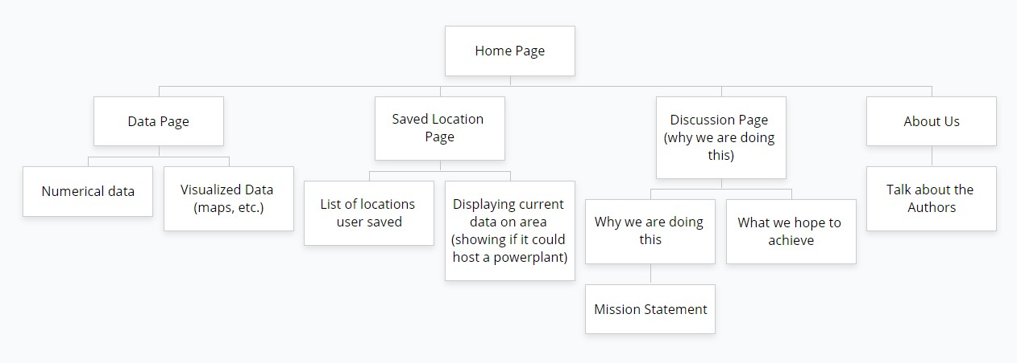

**Slide 8:**

Wireframe:

**Presentation Slide:**

1. Title slide - Introduce ourselves **(All)**
2. What is our project? Explain the NASA project **(Ben)**
3. What are we doing? Our goals? **(Catherine)**
4. Stakeholders - Who’s our target audience? **(Ishita)**
5. Basic Schedule - When do we plan on getting things done? **(Ryan)**
6. List of technologies **(Ishita)**
7. Basic sitemap **(Ben)**
8. Wireframe **(Ben)**
9. Conclusion/Questions